Microcystis wesenbergii (Komárek) Komárek ex Komárek 2006

Phylum: Cyanobacteriophyta
Class: Cyanophyceae
Order: Chroococcales

Habitat: planktonic, pelagic
Distinctive features: The largest-cell species of the chroococcalean cyanobacteria in Lake Kinneret. Colonies of spherical cells embedded in mucilage that has a distinct border. Common but never dominant.
Organization: colonial
Color: dark brown
Cell shape: sphere
Colony shape: spherical, elongate or lobate
Cell diameter (D): 3.4 – 7.5 μm, median: 5.5 μm (N=402)
Cell biovolume: 20 – 220 μm³, median: 90 μm³
Biovolume equation: Sphere V, µm³ = 4/3 p (D/2)³
Colony diameter: ~ 100 µm
Cells per colony: 10-300
Morphological features: Colonies initially spherical, later becoming elongate and intensely lobate, often with distincet holes (clathrate), sometimes composed of sub-colonies. Cells arrannged randomly rarely densely, in young colonies near the colony surface. The cells are embedded in colorless smooth, firm distinctly delimited mucilage with a refractive outline. The gelatinous margin extends 3-6 µm beyond the cell aggregations. Cells are spherical with distinct aerotopes, 4.0-7.5 µm in diameter (McGregor et al. 2007).
Plate 1. Microcystis wesenbergii from Lake Kinneret, showing its relatively large cells embedded in mucilage with a distinct edge. Photo by Alla Alster, May 2006.
Plate 2. Microcystis wesenbergii from Lake Kinneret, showing a colony made of several lobes. Photo by Alla Alster, May2006, Sta. A.
Ecology:
Microcystis wesenbergii is one of the common species of cyanobacteria occurring in Lake Kinneret (Fig. 1), but it was never dominant and never recorded to form a bloom (although it did form a bloom in Agmon-Hula in summer 2020). The species was not counted at all prior to 1998. It was more abundant during 1998-2009 than later (Fig. 1). Since July 2024 and until writing this item (July 2026) it was not found at all in Kinneret phytoplankton samples (data not shown). The species is more abundant from March to August, less abundant in winter (Fig. 2a). Colony size shows the opposite annual cycle, with more cells per colony in winter, less in summer (Fig. 2b). Cell volume fluctuates within a small amplitude around the multiannual median of 90 µm³ (Fig. 2c).
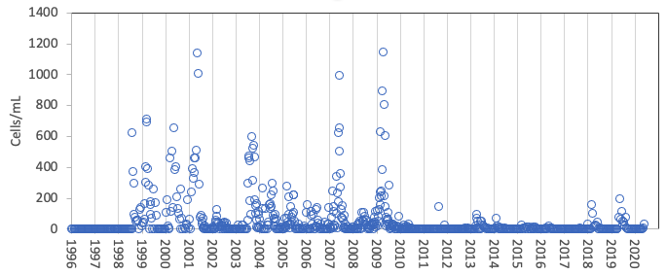
Figure 1. Time series of Microcystis wesenbergii abundance (cells mL⁻¹), Lake Kinneret, 1996-2020.
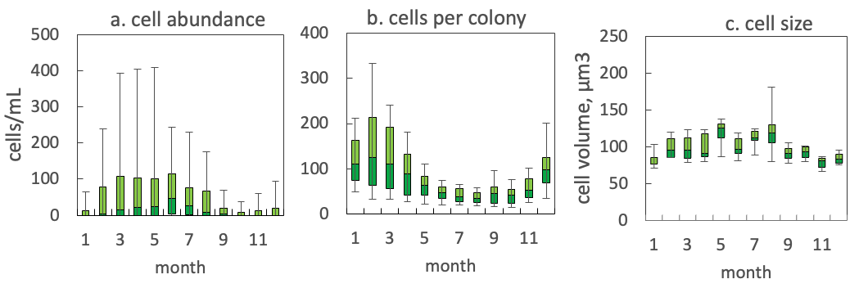
Figure 2. The annual pattern of Microcystis wesenbergii parameters, based on data for 1998-2020: (a) water column cell abundance; (b) number of cells per colony; (c) cell volume. Statistics shown are: median – middle line; 25th to 75th percentiles – box content; 90th and 10th percentiles - top and bottom bars, respectively.

Physiological features: Like other species of Microcystis, M. wesenbergii is known to produce toxins. The toxicity of Kinneret M. wesenbergii was never tested because it doesn’t form blooms and we do not have a culture of it.

Environmental conditions:
M. wesenbergii abundance is independent of water temperature, mixing depth, euphotic zone depth, alkalinity and calcium concentrations. Abundance increases with pH, from pH 8 till about pH 9.2, and with DON, till about 0.3 mg L⁻¹. All abundance peaks occurred at NH₄ < 25 µg L⁻¹ and Norg around 0.4 mg L⁻¹. Colony size (=number of cells per colony) decllined with increasing temperature, increased with calsium and alkalinity and was independent of nitrate, ammonium and DON concentrations.
Cite this record as:
Tamar Zohary, Alla Alster. [Date when Item was last updated]. Electronic publication. Israel Oceanographic & Limnological Research. [Date when last accessed].
Further reading:
Komárek J, Anagnostidis K. 1999. Cyanoprokaryota. 1. Chroococcales. In: Süßwasserflora von Mitteleuropa. Begründet von A. Pascher. Band 19/1. (Ettl H, Gärtner G, Heynig H, Mollenhauer D, Eds), pp. 1-548. Heidelberg & Berlin: Spektrum, Akademischer Verlag.
McGregor G, Fabbro LD, Lobegeiger JS. 2007. Freshwater planktic Chroococcales (Cyanoprokaryota) from North-Eastern Australia: a morphological evaluation. Nova Hedwigia 84(3/4): 299-331.

Genus species Authority Year
[Thumbnail photo here]

Phylum: Cyanobacteriophyta
Class: Cyanophyceae
Order: Chroococcales

Habitat: benthos, littoral
Distinctive features: colonial, forming masses in shallow waters
Organization: flagellated single cells
Color: yellow to golden-brown
Cell shape: mashroom-like, close to a sphere
Colony shape:
Cell diameter (D): 7.6 – 12.3 μm, median: 9.7 μm (N=587). Cell diameter varies significantly over an annual cycle, making it necessary to measure it routinely.
Cell length (L): ___
Cell biovolume: 230 – 1000 μm³, median: 470 μm³. Larger cell size in winter, smaller in summer (see Fig. 2b).
Biovolume equation: Sphere V, μm³ = 4/3 π (D/2)³. (or: regression eqn. based on >500 measurements of both D and L with V computed for a prolate sphaeroid).
Filament length:
Cells per filament:
Colony diameter:
Cells per colony:

Morphological features: text description
Plate 1. with 1 or more photos of the species, and descriptive text below each photo.Photo by Alla Alster.
Ecology: text description
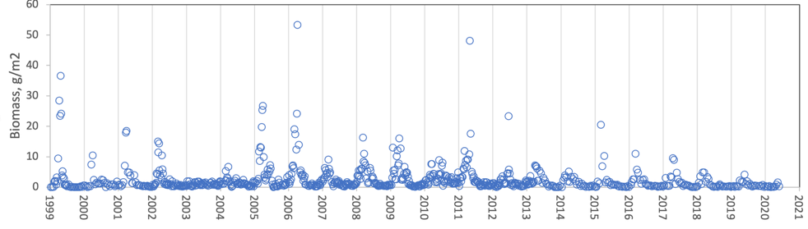
Figure 1. Time series of P. elpatiewskyi mean epilimnion cell abundance (cells mL⁻¹) [or: depth-integrated wet-weight biomass (g m⁻²), Lake Kinneret, 1999-2020.
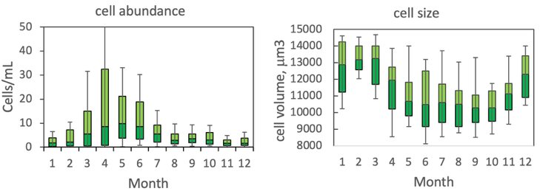
Figure 2. The annual pattern of water column cell abundance (left) and volume per cell (right) P. elpatiewskyi, based on data for 1978-2020. Statistics shown are: median – middle line; 25th to 75th percentiles – box content; 90th and 10th percentiles - top and bottom bars, respectively.

Fonts: 12 for numbers, 14 for axis labels. [Titles: a. cell abundance, b. cell size.] Bar colors: light green above median, strong green below media. Black borderline.
Physiological features:
Environmental conditions:
Figure 3. Gymnodinium abundance (cells mL⁻¹) vs. environmental parameters recorded at the site and time of sampling, showing tendency for higher cell concentrations at...
Cite this record as:
Tamar Zohary, Alla Alster. [Date when Item was last updated]. Electronic publication. Israel Oceanographic & Limnological Research. [Date when last accessed].
Further reading:

